**2017 EST Revision Document**

**Yr 12 Essentials Mathematics**

**Baldivis Secondary College**

**Basic Information**

The EST is under standard test conditions.

Duration = 50 min

EST Date = Wednesday 24th May (Week 5)

Additional Items

* **A calculator of the type used in school-based assessments for this course (basic scientific preferred but not necessary)**
* **One A4 doubled-sided page of notes**

**Content that the EST is based upon.**

**Cartesian plane**

3.3.1  demonstrate familiarity with Cartesian co‐ordinates in two dimensions by plotting points on the Cartesian plane

3.3.2  generate tables of values for linear functions drawn from practical contexts

3.3.3  graph linear functions drawn from practical contexts with pencil and paper and with graphing software

**Using graphs**

3.3.4  interpret and use graphs in practical situations, including travel graphs, time series and conversion graphs

3.3.5  draw graphs from given data to represent practical situations

3.3.7  identify the rate of change of the dependent variable, relating it to the difference pattern in a table and the slope of an associated line drawn from practical contexts

3.3.8  determine and describe the significance of the vertical intercept in practical situations

3.3.9  use the rate of change and the initial value to determine the linear relationship in practical situations

3.3.10  interpret the point of intersection and other important features of given graphs of two linear functions drawn from practical contexts; for example*,* the ‘break‐even’ point

**Bivariate scatterplots**

3.4.12  describe the patterns and features of bivariate data

3.4.13  describe the association between two numerical variables in terms of direction (positive/negative), form (linear/non‐linear) and strength(strong/moderate/weak)

**Trend line**

3.4.15  fit a trend line by eye

3.4.17  use the trend line to make predictions, both by interpolation and extrapolation

3.4.18  recognise the dangers of extrapolation

3.4.19  distinguish between causality and association through examples

**Practice EST #2 Bivariate Data** -

Name: Mark: /26

**Time: 45 minutes**

The time taken to build a wall and the number of workers involved was recorded.

Here are the results:

|  |  |  |  |  |  |  |  |  |  |  |  |  |  |  |
| --- | --- | --- | --- | --- | --- | --- | --- | --- | --- | --- | --- | --- | --- | --- |
| No. of workers | 3 | 10 | 6 | 14 | 2 | 12 | 4 | 5 | 18 | 3 | 8 | 15 | 12 | 8 |
| Days taken | 15 | 7 | 10 | 6 | 18 | 8 | 11 | 14 | 2 | 17 | 8 | 4 | 7 | 12 |

1. [ 10 marks]

Draw a scatter graph of this information. Place the number of workers on the x-axis.

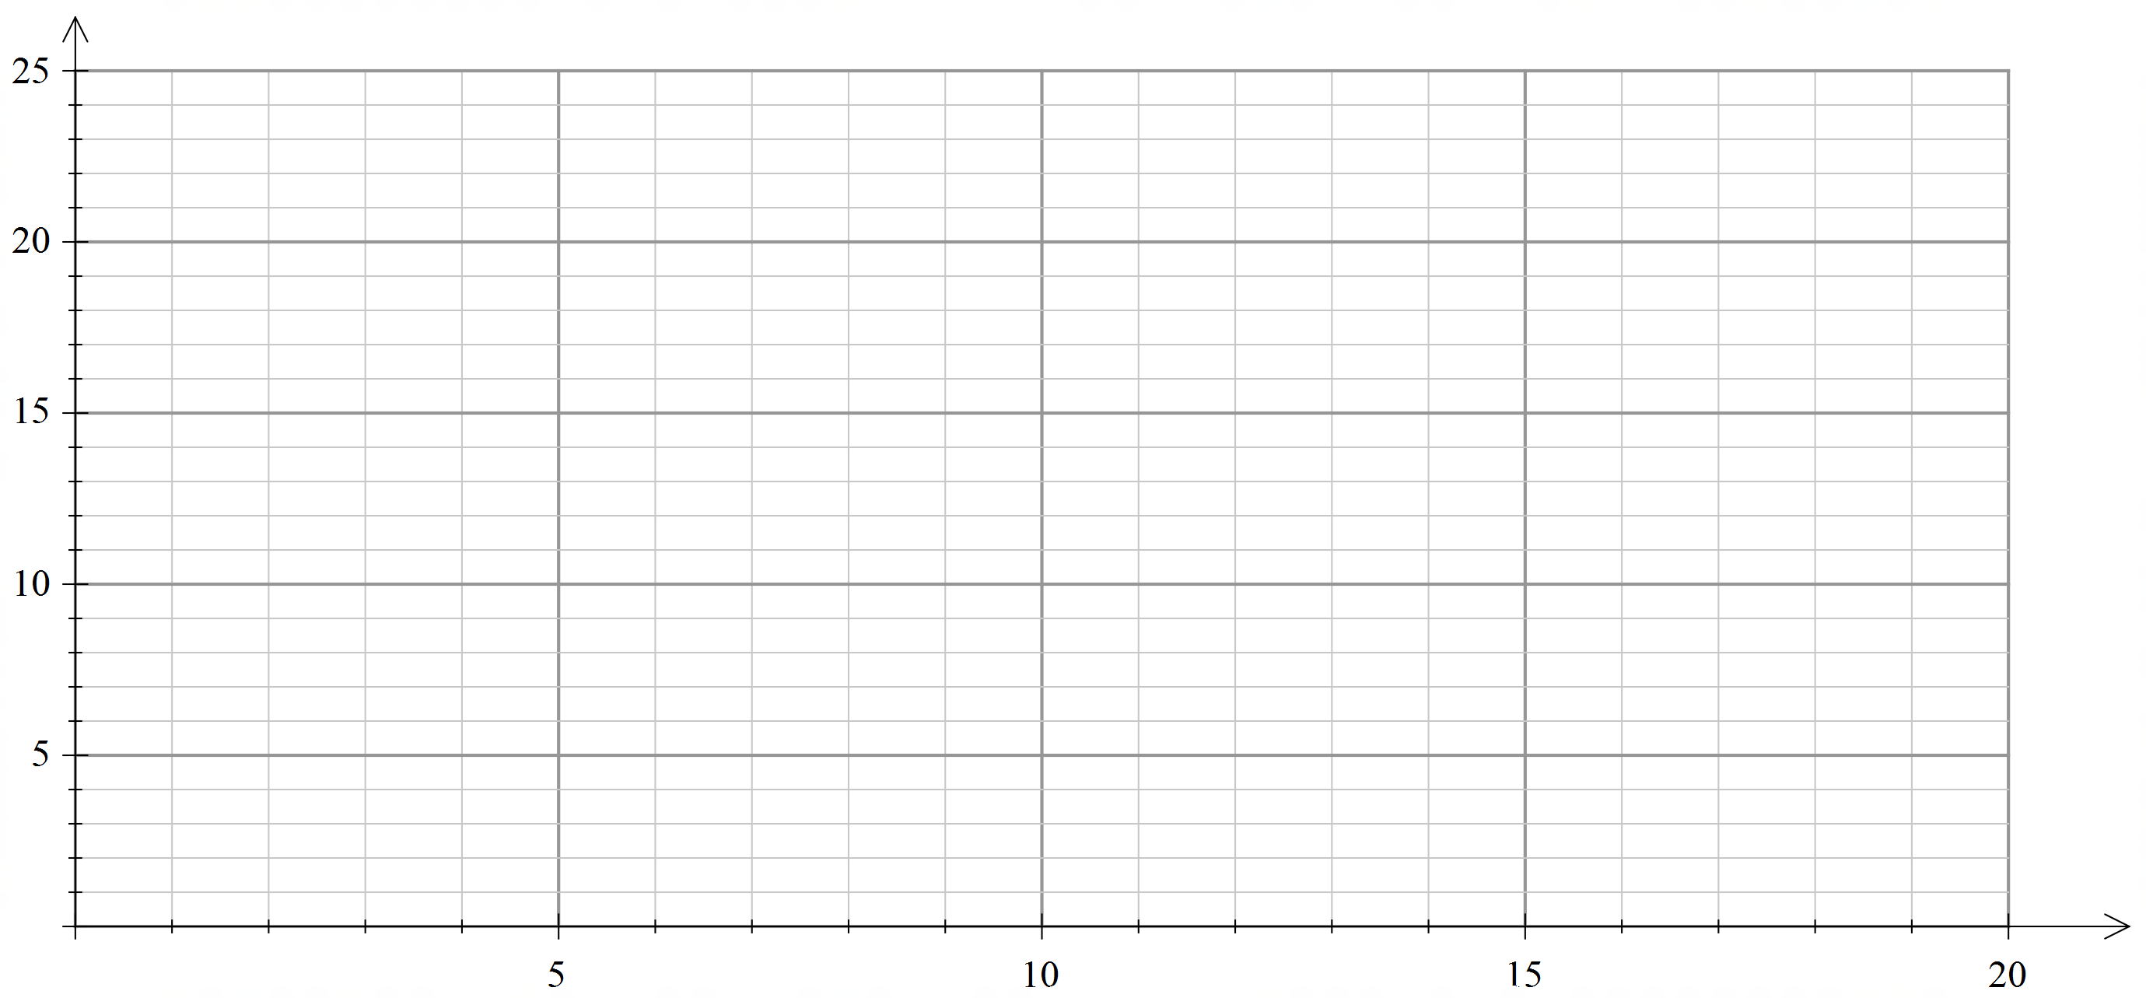

1. [ 2 marks]

Draw a trend line on the graph.

1. [3 marks]

Comment on the association between the number of workers and the days taken to build the wall.

1. [3 marks]

Use interpolation on your trend line to predict how long it would take for seven workers to build the wall. Show this clearly on your graph.

1. [2 marks]

Use extrapolation on your trend line to predict how long it would take for one worker to build the wall. Show this clearly on your graph.

1. [ 2 marks]

Which of your predictions would be more accurate and why?

1. [ 2 marks]

If the number of days was changed to the number of hours, would the association change?

1. [2 marks]

This data shows a relationship between age and weight.

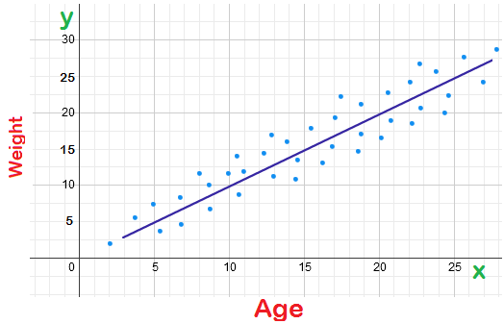

Does this data show that an increase in age causes an increase in weight? Explain.